NEW-A133-Dis-Eur-Germany-Hohe Fels-Female Figurine

[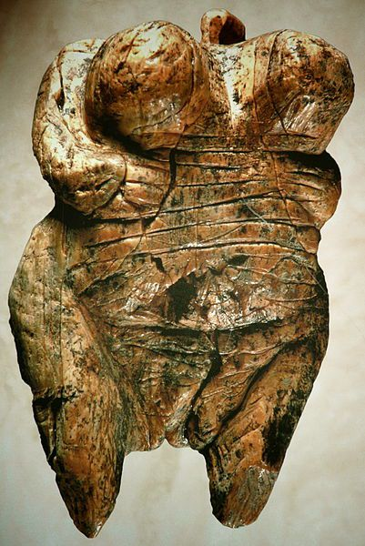](https://marcivermeersch.files.wordpress.com/2011/12/wordpress-venushohlefels.jpg)

Fig. 1. Venus figurine from Hohe Fels Cave, Schwaben, Germany

**Formal Label:** Venus figurine from Hohe Fels Cave, Schwaben, Germany

**Display Description:** Until the discovery of this figurine by Nicholas Conard in 2008, animals and therianthropic imagery dominated the known figurines from the Swabian Aurignacian: female figurines were entirely unknown (Floss and Rouquerol 2007; Hahn and Kraft 1986). This figurine was found in the deepest layers of the Hole Fels Cave. (estimated between 35,000 and 40,000 cal BP) (calibrated date before present), making it the oldest European Venus figurine (Conard 2009).

**Accession Number: A133**

**LC Classification:** GN772.2.M6

**Date or Time Horizon:** **40,000-35,000 cal BP**.

**Geographical Area:** Schwaben Jura, Germany.

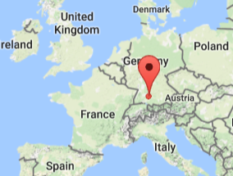 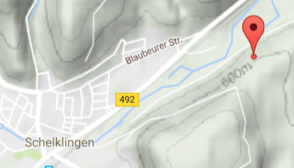

**Figs. 2-3. Map, Hohe Fels Cave from** <https://www.google.com/maps/place//@47.6151055,-1.6433072>**.**

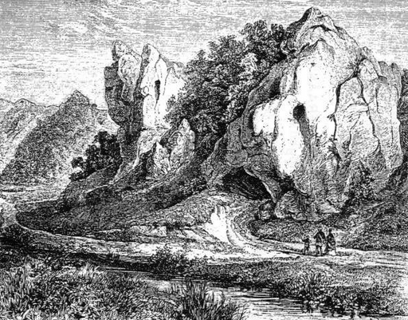

**Fig. 4. View of Hohe Fels Cave ca 1750 in which the shape of the rock in which the cave is situated looks like a human face or a simulacrum, which may have enhanced its attractiveness for the early humans to use it for such a long duration. From** <http://www.ancient-wisdom.com/Images/countries/German%20pics/hohle%20fels.jpg>

**Cultural Affiliation:** **Upper Paleolithic**

**Medium: mammoth ivory**

**Dimensions: H** 5.97 mm; W 3.46 mm   
**Weight:** 33.3 gms

**Provenance:** found in the Hohe Fels cave in 2008 by Nicholas Conard (University of Tübingen)

**Condition:** museum replica in resin

**Discussion:**

The figurine portrays a sexually idealized, heavily built woman with large breasts, buttocks, belly and a vagina that are all disproportionate, suggesting that these sexual features were associated with child-bearing, which was, presumably, a chief aspect of security and survival when one only lived to thirty or thirty-five. Thus, other attributes are lacking emphasis such as her face, arms and legs, which created a figurine without an individual identity. Due to unknown circumstances, this figurine was shattered into at least seven fragments of which six have been recovered, but the left arm and shoulder are still missing (Conard 2009).

A number of engravings are worth noting: anterior U-shaped engravings on the breasts and shoulders; posterior vertically engraved lines; short, deep engraved lines on the breasts, arms and hands. These engravings are similar to those on other Swabian Aurignacian ivory figurines 5,000 years later such as the Venus of Willendorf, suggesting an appreciation for a very conservative engraving grammar of female figurines. Pigments, such as red ochre or cinnabar, are entirely lacking. Many of the features, including the extreme emphasis on sexual attributes and lack of emphasis on the head, face and arms and legs, resemble aspects of Gravettian figurines dating to 22,000-27,000 BP (Svoboda 2008; Roebroeks, Mussi, Svoboda, Fennema, eds. 2000)

**References:**

Conard, Nicholas J. 2009. **“**A female figurine from the basal Aurignacian of Hohle Fels Cave in southwestern Germany,” *Nature*, 459 14 May 248-252

Floss, H. & Rouquerol, N., eds. 2007. *Les Chemins de l’Art Aurignacien en Europe / Das*

*Aurignacien und die Anfánge der Kunst in Europa*. Aurignac: Éditions Musée-forum Aurignac.

Hahn, J. Kraft und Aggression. 1986. *Die Botschaft der Eiszeitkunst im Aurignacien Süddeutschlands.* Tübingen: Archaeologica Venatoria.

Roebroeks, W., Mussi, M., Svoboda, J. & Fennema, K. eds. 2000. *Hunters of the Golden*

*Age*. Leiden: Analecta Praehistorica Leidensia, 2000).

Svoboda, J.A., 2008. *Petřkovice: on shouldered points and female figurines*. Brno: Academy of Sciences of the Czech Republic, Institute of Archaeology at Brno.